

CS110: LAB 03

**Conditional Statements-Decision Making**

**Muhammad Mujtaba**

**CMD ID: 540040**

[mmujtaba.bese25seecs@seecs.edu.pk](mailto:mmujtaba.bese25seecs@seecs.edu.pk)

**Class:** BESE 16B

**Batch:** 2k25

# Task 1 [CLO 1]:

## CODE

#include <iostream>

// utility; mainly used to improve readability

inline bool isDivisible(int input, int checkNum)

{

return input % checkNum == 0;

}

int main()

{

int input_num;

std::cout << "Enter a Number to check divisibility of: ";

std::cin >> input_num;

std::cout << std::endl;

if (isDivisible(input_num, 2))

{

std::cout << "You entered an EVEN number (" << input_num << ")\n";

if (isDivisible(input_num, 4))

{

std::cout << input_num << " is divisible by 4\n";

}

if (isDivisible(input_num, 6))

{

std::cout << input_num << " is divisible by 6\n";

}

}

else

{

std::cout << "You entered an ODD number (" << input_num << ")\n";

if (isDivisible(input_num, 3))

{

std::cout << input_num << " is divisible by 3\n";

}

if (isDivisible(input_num, 5))

{

std::cout << input_num << " is divisible by 5\n";

}

}

// ignore is used to clear previous inputs from user

std::cin.ignore();

std::cin.get();

return 0;

}

## OUTPUT

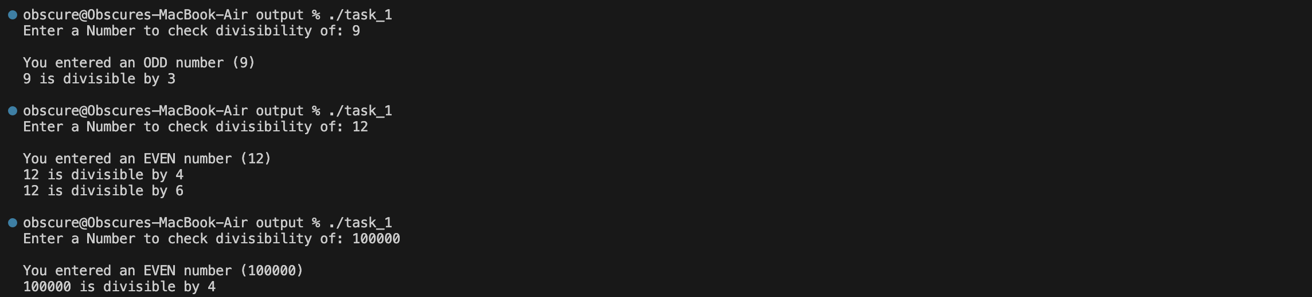

# Task 2 [CLO 1]:

## CODE

#include <iostream>

#include <string>

int main()

{

float marks;

char grade = ' ';

std::cout << "Enter marks: ";

std::cin >> marks;

std::cout << "\n";

if (marks >= 70)

grade = 'A';

else if (marks >= 60 && marks < 70)

// even though condition `marks < 70` is not required

// it is included to imporve readability

grade = '+'; // assigning unique character

else if (marks >= 50 && marks < 60)

grade = 'B';

else if (marks >= 40 && marks < 50)

grade = 'C';

else if (marks < 40)

grade = 'F';

// when printing convert '+' to "B+" (char -> std::string)

// converting because string allows storing multiple characters

std::string grade_printable;

if (grade == '+')

grade_printable = "B+";

else

grade_printable = grade;

std::cout << marks << " marks equate to grade " << grade_printable << std::endl;

switch (grade)

{

case 'A':

std::cout << "Outstanding!" << std::endl;

break;

case '+':

std::cout << "Excellent!" << std::endl;

break;

case 'B':

std::cout << "Very Good!" << std::endl;

break;

case 'C':

std::cout << "Good!" << std::endl;

break;

case 'F':

std::cout << "Fail!" << std::endl;

break;

default:

std::cout << "THIS WILL NEVER PRINT" << std::endl;

break;

}

// ignore is used to clear previous inputs from user

std::cin.ignore();

std::cin.get();

return 0;

}

## OUTPUT

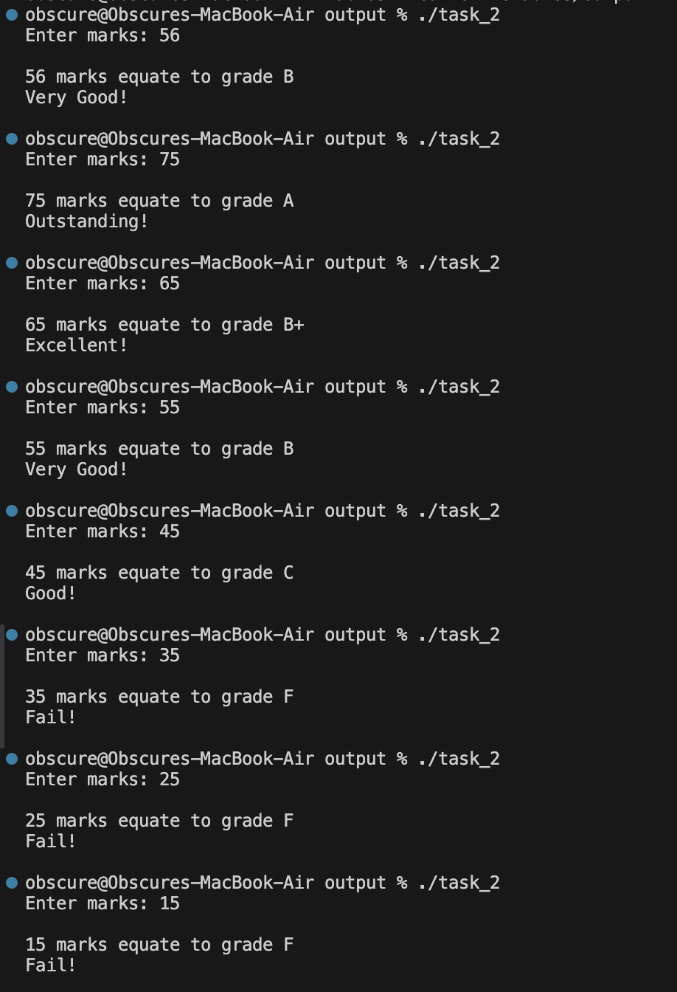

# Task 3 [CLO 1]:

## CODE

#include <iostream>

#include <iomanip> // manipulators for printRow

float getPrice(int product_id);

void printRow(const char *colA, const char *colB);

void printProductTable();

int main()

{

int product_id, quantity;

float total = 0.f;

float discount = 0.f;

printProductTable();

// loop to run until valid value for product id is entered by user

while (true)

{

std::cout << "Enter Product ID: ";

std::cin >> product_id;

std::cout << "\n";

if (getPrice(product_id) == -1)

{

std::cout << "Please input a valid value from the table";

printProductTable();

continue;

}

// break out of loop when value is validated

break;

}

std::cout << "Enter Quantity: ";

std::cin >> quantity;

std::cout << "\n";

total = getPrice(product_id) * quantity;

// apply 10% discount is user buys more than 5 items

if (quantity > 5)

discount = total * (10.f / 100);

std::cout << "Final amount owed: $" << total - discount << std::endl;

// print discount info

if (discount > 0)

{

std::cout << std::endl;

std::cout << "Discount Applied: $" << discount << std::endl;

std::cout << "Without Discount: $" << total << std::endl;

}

// ignore is used to clear previous inputs from user

std::cin.ignore();

std::cin.get();

return 0;

}

float getPrice(int product_id)

{

switch (product_id)

{

// no break is needed as return does the job

case 1:

return 2.98f;

case 2:

return 4.5f;

case 3:

return 9.98f;

case 4:

return 4.49f;

case 5:

return 6.87f;

default:

return -1.f;

}

}

void printRow(const char *colA, const char *colB)

{

std::cout << " " << std::left << std::setw(4) << colA << " | " << colB << "\n";

}

// print a formatted table that shows all product;

void printProductTable()

{

const char *LINES = "--------------";

std::cout << "\n\n"

<< LINES << "\n";

printRow("ID", "Price");

std::cout << LINES << "\n";

printRow("1", "$2.98");

printRow("2", "$4.50");

printRow("3", "$9.98");

printRow("4", "$4.49");

printRow("5", "$6.87");

std::cout << LINES << "\n\n";

}

## OUTPUT

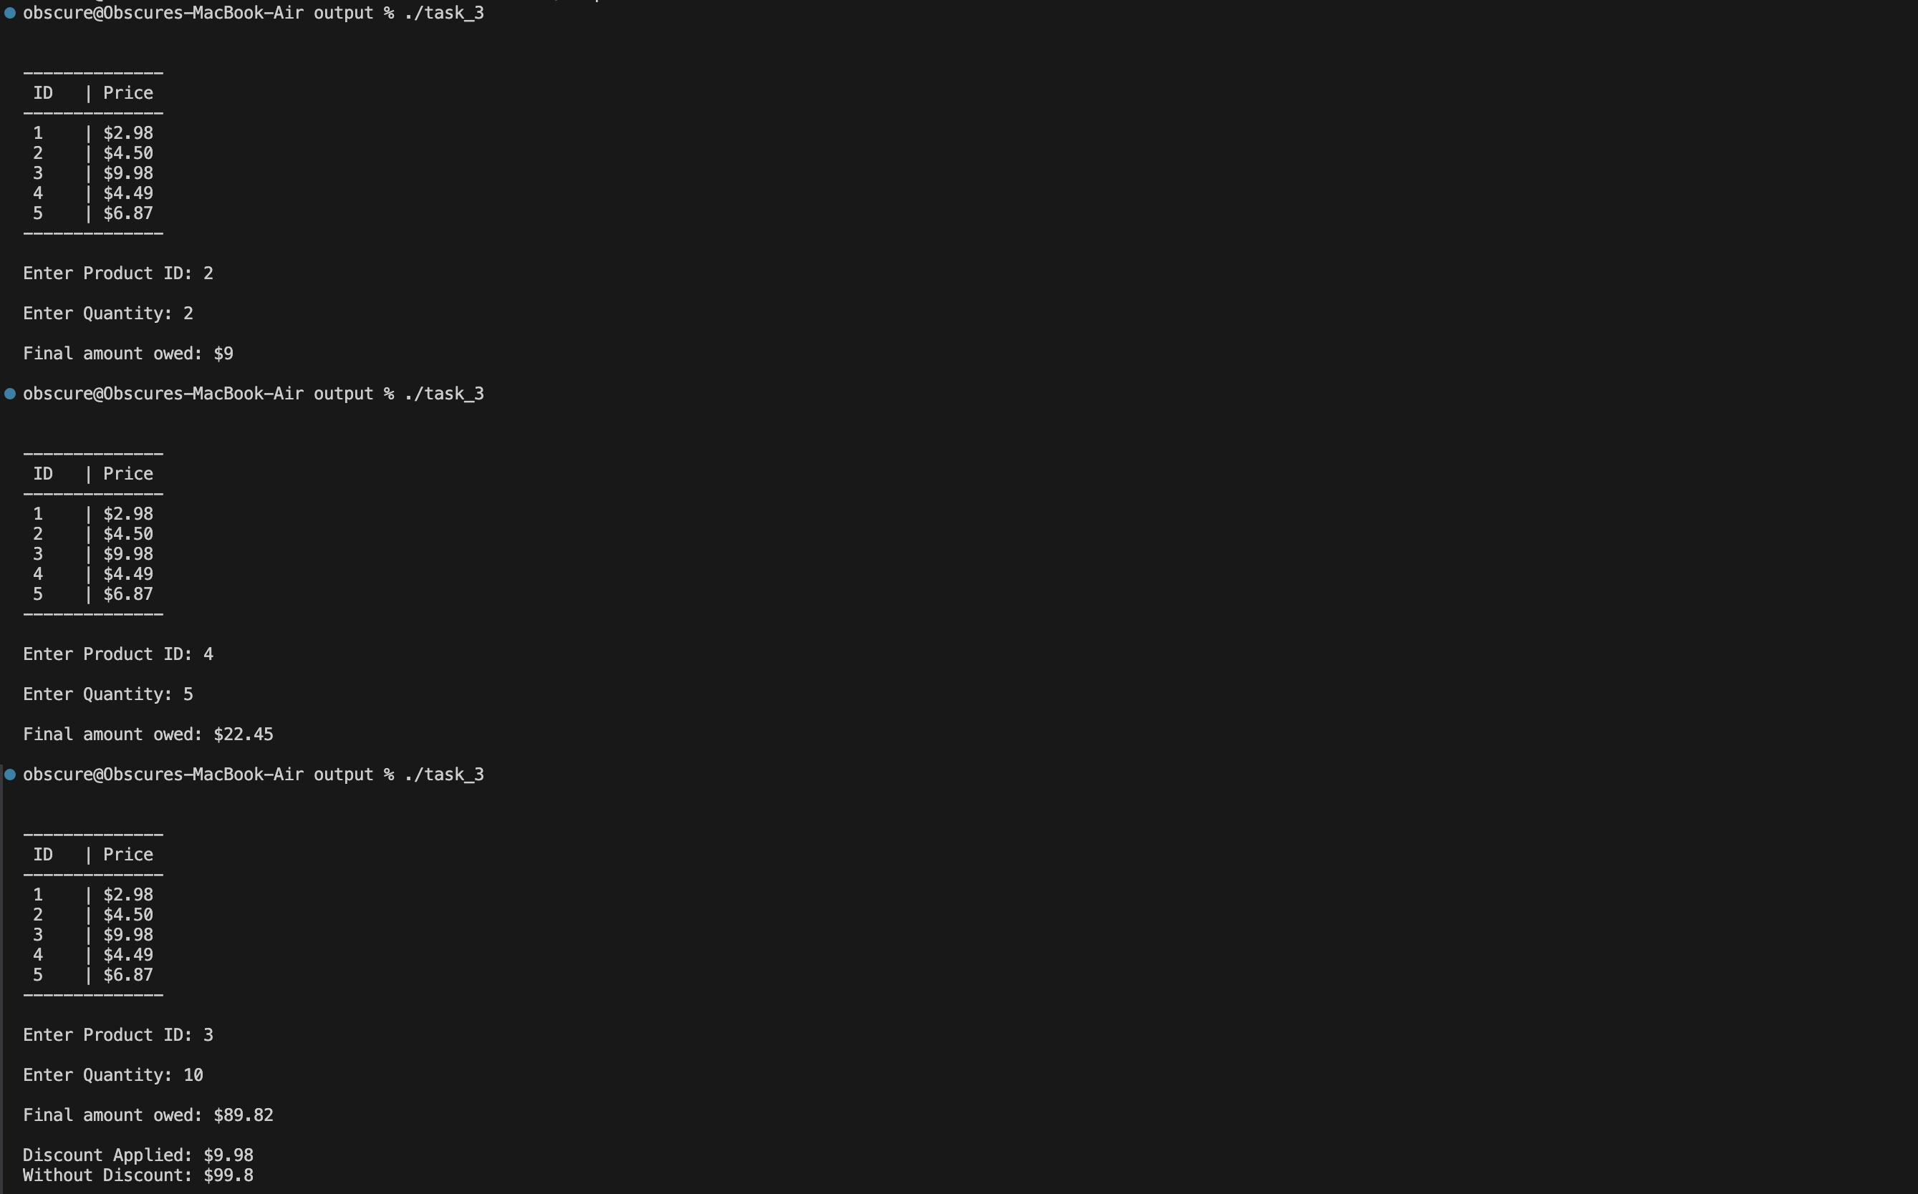

# Task 4 [CLO 1]:

## CODE

#include <iostream>

int main()

{

float annualSales;

float bonus;

std::cout << "Enter Annual Sales: $";

std::cin >> annualSales;

std::cout << "\n";

if (annualSales >= 15'000)

{

bonus = annualSales * (2.f / 100);

}

else

{

bonus = annualSales * (1.5f / 100);

}

std::cout << "Bonus: $" << bonus << "\n";

// ignore is used to clear previous inputs from user

std::cin.ignore();

std::cin.get();

return 0;

}

## OUTPUT

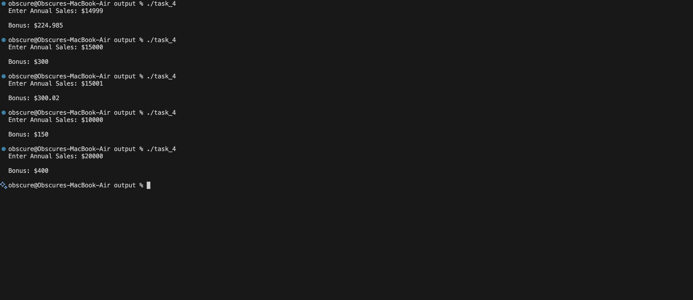

# Task 5 [CLO 1]:

## CODE

#include <iostream>

void printCase(char a)

{

// WORKING PRINCIPLE

// char is basically be thought of as a unsigned 8 bit integer

// the computer stores a map from each possible number 0-255 to a specific symbol

// in this map, small, capital, digits etc are sequential, comes after one another

// by using only (char) >= (char) both are implicitely converted to int and compared

// as said since digits are mapped sequentially the number representation of a small alphabet is between the number representation of `a` and `z`

// same holds for capital letters and digits

if (a >= (int)'a' && a <= (int)'z')

std::cout << "You entered SMALL letter \'" << a << "\'";

else if (a >= 'A' && a <= 'Z')

std::cout << "You entered CAPITAL letter \'" << a << "\'";

else if (a >= '0' && a <= '9')

std::cout << "You entered DIGIT \'" << a << "\'";

else

std::cout << "You entered SPECIAL character \'" << a << "\'";

// (a >= 'a' && a <= 'z') can also be written as

// (a >= (int)'a' && a <= (int)'z')

// above is not used as this clutters the code

std::cout << "\n";

}

int main()

{

char inputChar;

std::cout << "Enter a character: ";

std::cin >> inputChar;

std::cout << "\n";

printCase(inputChar);

// ignore is used to clear previous inputs from user

std::cin.ignore();

std::cin.get();

return 0;

}

## OUTPUT

